

|  |  |
| --- | --- |
| **Url** | https://www.aum.edu.kw/english/campus-life/athletics-sports-center |
| **Address** | 29.164330992151527, 48.09828983655695 |
| **Video** | https://www.youtube.com/watch?v=ZrDR03anmTY&list=PLVTllUPxuWHAOW_ADhOajg0i6nNIEj2oa |

Our world-class facility offers an adequate environment for both students and staff. Considered one of the largest university sports complexes in Kuwait and the Middle East, the AUM Sports Center gives the AUM community free access to a wide range of indoor and outdoor sporting facilities.

As part of AUM’s efforts to promote a culture of health and wellbeing for the students and everyone on campus, a modern and large Sports Center is available, which includes indoor and outdoor playgrounds, in addition to many other sections. Professional trainers at the gym and specialized coaches for different kind of sports are also present dedicating their time to physically and mentally prepare AUM students to perform their best and prepare for competitions. The students have achieved outstanding results locally, regionally, and internationally.

Our world-class facility offers an adequate environment for both students and staff. Considered one of the largest university sports complexes in Kuwait and the Middle East, the AUM Sports Center gives the AUM community free access to a wide range of indoor and outdoor sporting facilities.  
The main objective of the Sports Center is to enhance staff and student’s health awareness and assist them in improving their performance through programs adherent to different methodologies in sports science.

### [Indoor Facilities](https://www.aum.edu.kw/english/campus-life/athletics-sports-center/indoor-facilities)

* The facility is divided into both male and female sections, with three separate floors that divide faculty from students with each having their respective spacious fitness suite with a full range of state-of-the-art cardiovascular equipment, fixed resistance machines, and free weights.
* The Gym hosts five large multi-purpose rooms; fitting up to 30 individuals, that can cater to martial arts, yoga, studio cycling, and floor-based exercises including dancing and gymnastics.
* Our fitness facilities include changing rooms, lockers and showers. Staff are always available to provide information, assist with using the equipment or attending classes, as well as provide fitness assistance.
* Instructors are always available at the gym to give inductions, personal programs, and training advice to students and staff.

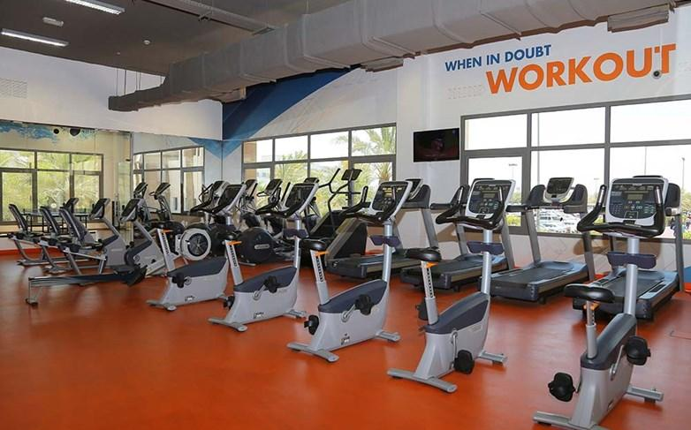

* VDS multi‐sports hall: one of the best venues in Kuwait for tournaments and games
* 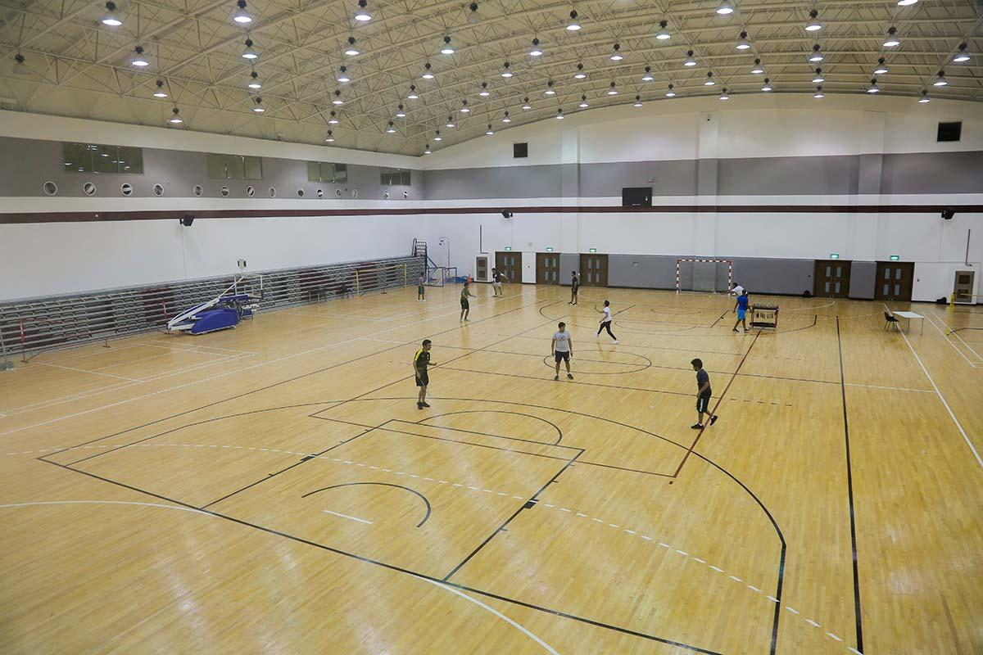(Basketball/ volleyball/handball/futsal/tennis/table tennis).
* 3 floors training center with 4 gyms equipped for cardio and weightlifting and
* 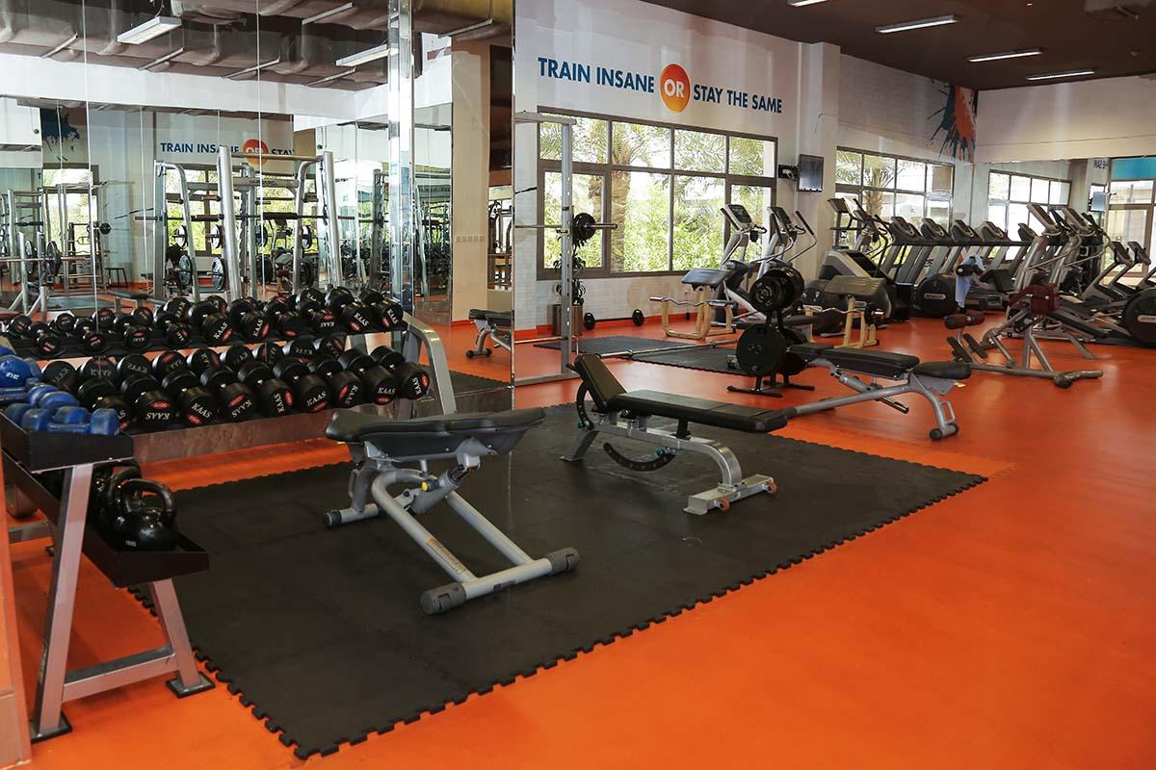Modern changing rooms and showers for males and females.
* 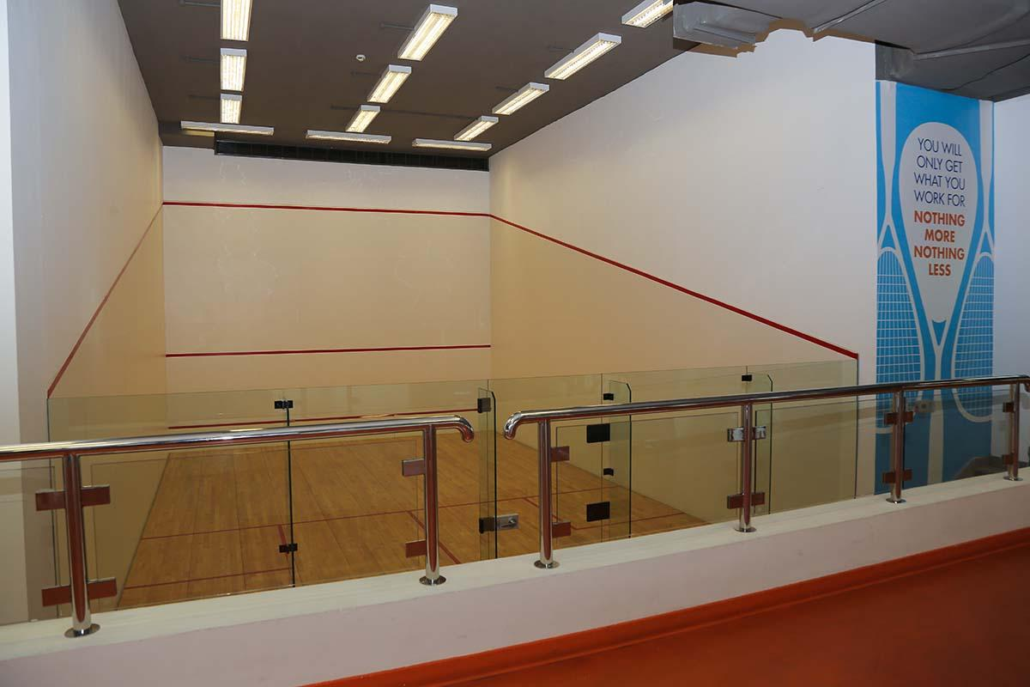  2 professional squash courts
* 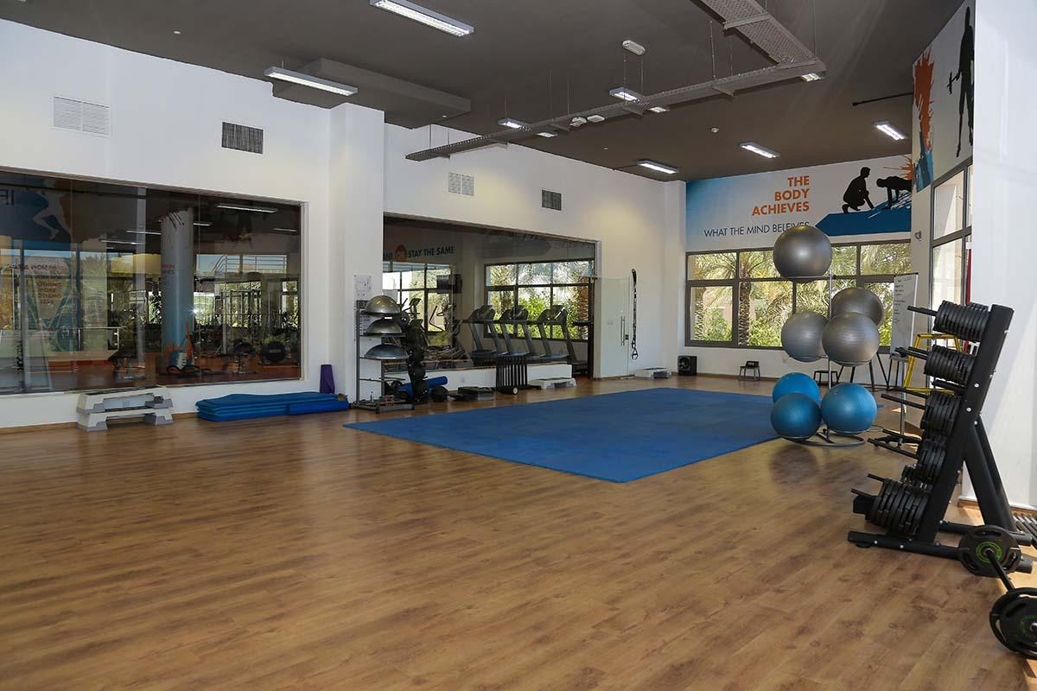8 multi‐purpose studios for all kind of fitness activities, such as aerobics, steps, Zumba, Yoga and Pilates, among others
* 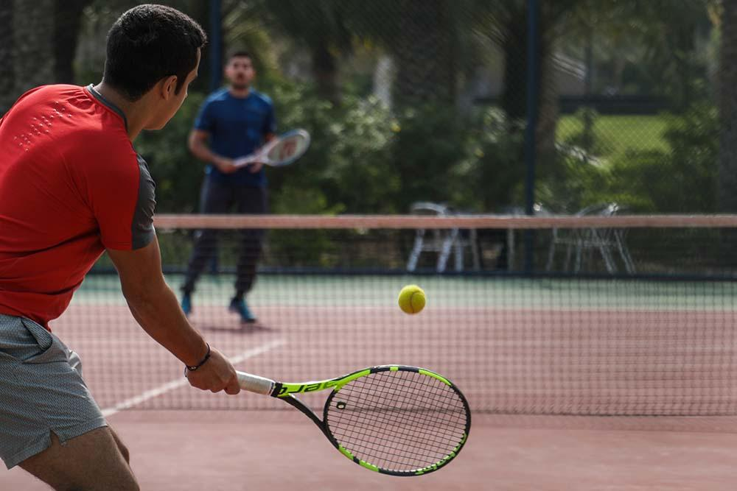The Tennis court at AUM is one of the top university tennis facilities in Kuwait and is operational throughout the year.

#### Padel Court: AUM constructed a Padel Court on campus given its fast-growing popularity among youth in Kuwait. AUM students can reserve the court between Sunday and Thursday from 10 AM to 8 PM via Moodle. All required equipment is provided for free by the AUM Sports Center.

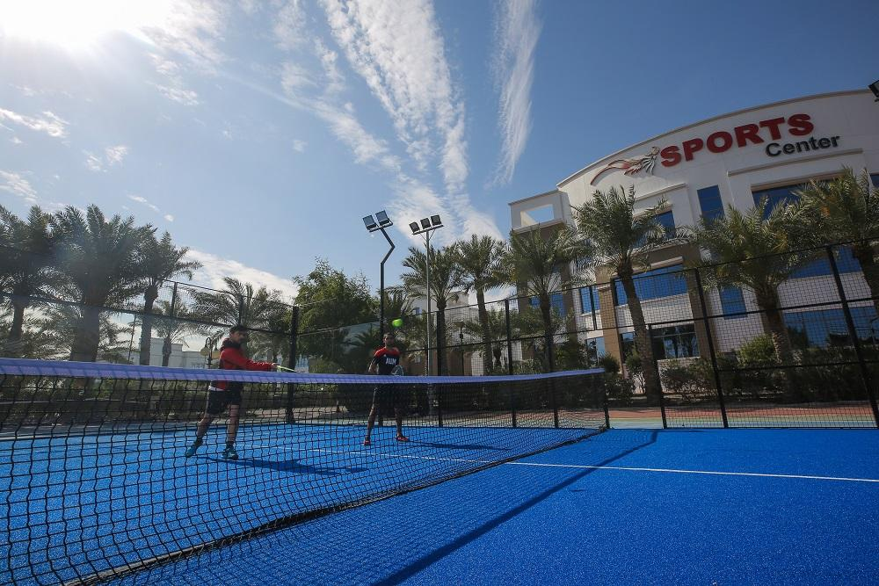

* AUM students have free year-round access to three outdoor volleyball and basketball courts, where they can book their game times via the Sports Center. AUM courts host several games annually for both men/women basketball and volleyball programs.

